**Project description**

**Report**

**Data Analytics Project (DEPI)**



**Data Dynamos**

For HR Data Analysis

**Project description**

**Data Analytics Project (DEPI)**

**Project Idea 3:**

Human Resources Dataset Analysis

**Objectives:**

* We will delve into a comprehensive analysis of our employee dataset, which comprises five key tables. Each table provides critical insights into various aspects of employee performance, satisfaction, and demographics. By examining these tables, we aim to uncover meaningful patterns and relationships that can inform strategic decisions within our organization.
* In addition to collecting additional data for comparison and taking several strategic decisions and working on preparing interactive reports, analyses and forecasts that help in making decisions and preparing this in a visual form to make it easier for decision makers to compare and create an artificial intelligence model equipped to answer any question that helps in making a decision.
* In addition to preparing a special report for each department to help it develop plans appropriate to the actual situation.

**Overview of Our Data:**

|  |  |
| --- | --- |
| **Employee Data** | A comprehensive list of employees, including demographic details such as age, gender, marital status, and job roles. |
| **Performance Rating Data** | Tracks individual performance metrics, capturing data from employee reviews and assessments over time. |
| **Education Level Data** | Provides insights into the education backgrounds of employees, highlighting their qualifications and the correlation with job performance and salary. |
| **Rating Level Data** | Details performance ratings for employees, evaluating their overall contributions and effectiveness in their roles. |
| **Satisfied Level Data** | This contains information on employee satisfaction ratings, categorized by various factors such as job satisfaction and work-life balance. |

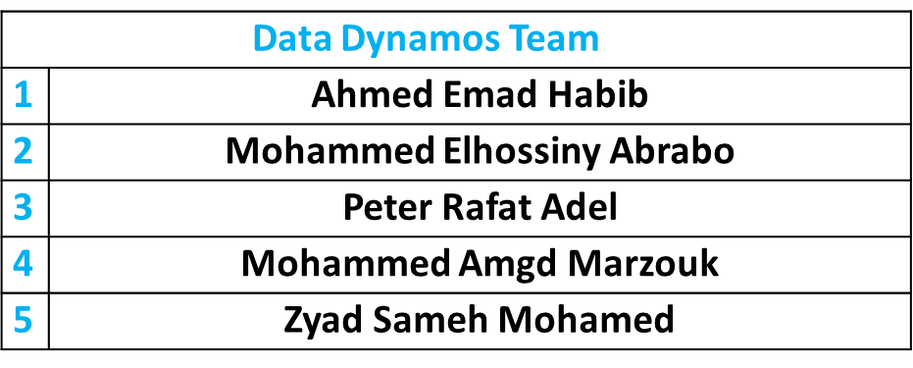**Team Members:**

**Tools:**

Excel, SQL, Python, Tableau, Power Bi, Looker Studio.

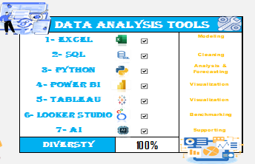



|  |
| --- |
| **Data Dynamos** |